




ALPHA-PIR
AIR DUCT SYSTEM
Premium quality and performance pre-insulated Polyisocyanurate air duct system.

PRODUCT CATALOGUE
6th Issue - October 2023

MEP for a Better Living

COMPANY PROFILE

DCL Certification for PIR panels
New Facility in Jabal Ali / Installation of new Phenolic (PF) line
The panel manufacturing facility was shifted to Jabal Ali Industrial to upgrade the size, introduce new sections and production lines and increase the overall production capacity to cover the increased demand from the local, regional and international markets in addition to introducing new products to cover new market segments. The current annual production capacity is 5 million square meters.

ISO 9001 Certification

ISO 14001 and OHSAS 18001 Certification
Certifire Certification for PIR and PF panels UL listing for PF duct system

ALPHA DUCTS LLC is one of the highly advanced and modernized manufacturers of insulation foam panels, pre-insulated air duct systems and accessories based in Dubai, United Arab Emirates and having an extensive international network to serve customers worldwide.
2004
2005
2006
2008
2009
2012
2013
2016
2018
Established
ALPHA DUCTS LLC was established in 2004 as a local manufacturing facility in Al Quoz, Dubai, UAE to meet the requirements of the local market.
Upgrade of existing Polyisocyanurate (PIR) line
It was upgraded in 2005 to a huge capacity manufacturing facility with fully automated machineries and qualified technicians for a worldwide supply.

ALPHA DUCTS LLC is manufacturing insulation panels and pre-insulated air duct systems in the brand name ALPHA which are prime quality insulation panels and air ducts meeting the international quality, health, safety, environment and fire standards.

DCL Certification for PF panels

Joined FJ Group
ALPHA DUCTS LLC is certified to the highest international standards of quality, occupational health, safety and environment: ISO 9001, ISO 14001 and ISO 45001.
ALPHA DUCTS LLC products are certified to the highest international air leakage, fire and safety standards: UL listing from Underwriters Laboratories, Certifire certification from Warringtonfire, DCL certification from Dubai Municipality and air leakage certification from BSRIA in addition to complying with BS and EN standards..

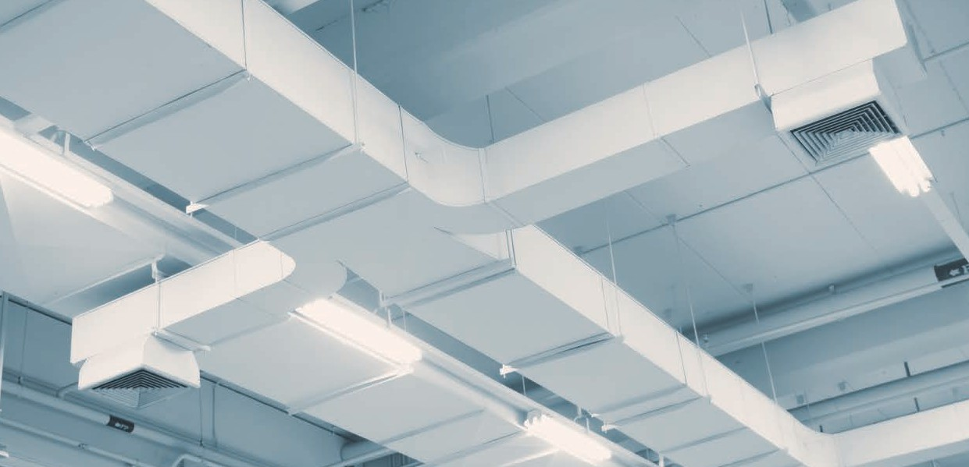
ALPHA-PIR air duct system is a lightweight premium quality and performance pre-insulated Polyisocyanurate air duct system for air distribution.

INTRODUCTION
ALPHA-PIR air duct system consists of ALPHA-PIR Polyisocyanurate panels, specified joining systems and range of accessories in addition to the recommended fabrication and installation procedures.
The ducts are fabricated in sections up to 4 m length and offer multiple advantages in reducing cost and energy usage when compared to the conventional sheet metal duct systems.
ALPHA-PIR air duct system is compatible with the standard sheet metal control dampers, fire dampers, access doors and supporting systems used in the conventional sheet metal duct systems.

RANGE AND LIMITATIONS
ALPHA-PIR air duct system is recommended to be used in the systems of supply, return, fresh air and exhaust for air conditioning, heating and ventilation within the below limits:


MAXIMUM PRESSURE:
2000 Pa positive and 750 Pa negative
SIZE:
Please refer to the fabrication and installation procedures. Any size can be fabricated after the technical consultation of ALPHA DUCTS LLC technical team.
MAXIMUM AIR VELOCITY:
25 m/s
TEMPERATURE:
Air temperature between -20°C and +110°C

ALPHA-PIR air duct system is recommended to be used in various types of projects: residential, commercial, mixed use, hotels and light industrial.
ALPHA-PIR air duct system is highly recommended to be used in high specifications projects like hospitals, food and beverage industry, pharmaceutical industry, air and hygiene controlled environments and many more where the usage of fiber insulation is not allowed.
ALPHA-PIR air duct system is recommended to be used for internal and external applications and can be installed in visible open areas, above false ceilings and within confined enclosures.
ALPHA-PIR air duct system should not be used in the following applications:
- Chemical, fumes and smoke exhaust systems.
- Kitchen and grease exhaust systems.
- Air systems carrying any type of solid particles.
- Fire resistant duct systems.
- Hot air systems where the air temperature exceeds +110°C.
- Air systems that do not have automatic temperature control as per the indicated range.

DESIGN AND PRESSURE DROP
ALPHA-PIR air duct system follows the same calculation and duct sizing methods used for the rectangular duct designing in the conventional sheet metal duct systems.
The pressure drop in ALPHA-PIR air duct system can be compared to the one in the conventional sheet metal duct systems. Therefore the pressure drop data from the sheet metal duct systems can be used for calculating the pressure drop in ALPHA-PIR air duct system.

ALPHA-PIR air duct system fabricated in line with the recommended fabrication procedure using the specified types of transverse joints and the specified accessories comply with the air leakage requirements as per HVCA DW144 standard.
AIR LEAKAGE

STANDARD | JOINT
HVCA DW144 | Male / Female | Polymer invisible flange | Aluminium invisible flange
 | Class C | Class C | Class C


ADVANTAGES AND BENEFITS

Light weight: The ducts fabricated from ALPHA-PIR panels have a considerably lower weight when compared to the conventional sheet metal ducts.

Installation speed: Because of the light weight, the ducts fabricated from ALPHA-PIR panels can be installed faster than the conventional sheet metal ducts and therefore offer a huge saving in installation time and manpower cost.

Environment friendly: ALPHA-PIR panels are CFC and HCFC free.

Moisture resistance: The usage of the aluminium foil facing makes ALPHA-PIR panels highly resistant to moisture and eliminates the need of a vapor barrier used with the traditional fiber insulation.

Health and safety: ALPHA-PIR panels are resistant to bacteria and microbes, fungal and mould growth, will not sustain vermin, are odorless and have a fiber free foam core.

Visible application: ALPHA-PIR air duct system is aesthetically pleasing in open to view applications.

External application: ALPHA-PIR air duct system can be used in external applications.

Air leakage: The recommended fabrication procedure allowing the combination of the suitable number of pieces in addition to the possibility of fabricating duct pieces in sections up to 4 m length will reduce the total number of joints in ALPHA-PIR air duct system compared to the conventional sheet metal duct systems. This will result in reducing the volume of air leakage in the full system.

MECHANICAL PROPERTIES
 |  | Thermal conductivity | 0.022 W/m.K | ASTM C518 at 10°C
 |  | Water vapor transmission | ZERO g/h.m2 | ASTM E96
 |  | Temperature range | -20°C and +110°C | As per standard practice
 |  | Minimum compressive strength | 200 kPa | ASTM D1621 at 10% deformation
 |  | Minimum flexural strength | 1200 kPa | ASTM C203
 |  | Closed cell content | 90% | BS EN ISO 4590

ALPHA-PIR PANELS

ALPHA-PIR panels consist of a formaldehyde free, fiber free, high performance rigid thermoset Polyisocyanurate foam core faced on both sides with an extremely durable, protective, low vapor permeability aluminium foil.
The foam core is produced using a CFC / HCFC free blowing agent having a zero Ozone Depletion Potential (ODP) and a Global Warming Potential (GWP) lower than 5.
The aluminium foil is bonded to the foam core by heat reaction during the manufacturing process without using additional adhesives. The aluminium foil is lacquered with a factory applied corrosion and UV resistant polymer coating.

ALPHA-PIR PANEL FOR INTERNAL USE

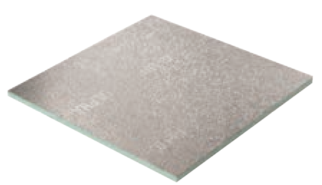
AD-PIR-12-10
Thickness : 12 mm
Minimum density : 50 kg/m3
Dimensions : 4000 mm x 1200 mm and 3000 mm x 1200 mm Aluminium foil finish : embossed / embossed
Aluminium foil thickness : 80 micron / 80 micron

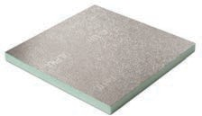
AD-PIR-20-10
Thickness : 20 mm
Minimum density : 50 kg/m3
Dimensions : 4000 mm x 1200 mm and 3000 mm x 1200 mm Aluminium foil finish : embossed / embossed
Aluminium foil thickness : 80 micron / 80 micron

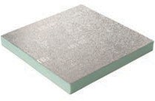
AD-PIR-30-10
Thickness : 30 mm
Minimum density : 50 kg/m3
Dimensions : 4000 mm x 1200 mm and 3000 mm x 1200 mm Aluminium foil finish : embossed / embossed
Aluminium foil thickness : 80 micron / 80 micron

ALPHA-PIR PANEL FOR EXTERNAL USE

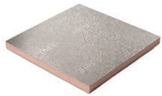
AD-PIR-20-20
Thickness : 20 mm
Minimum density : 60 kg/m3
Dimensions : 4000 mm x 1200 mm and 3000 mm x 1200 mm Aluminium foil finish : embossed / embossed
Aluminium foil thickness : 80 micron / 200 micron

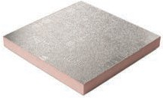
AD-PIR-30-20
Thickness : 30 mm
Minimum density : 60 kg/m3
Dimensions : 4000 mm x 1200 mm and 3000 mm x 1200 mm Aluminium foil finish : embossed / embossed
Aluminium foil thickness : 80 micron / 200 micron

ALPHA-PIR PANEL WITH SMOOTH FACER

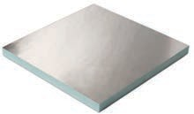
AD-PIR-S-20-10
Thickness : 20 mm
Minimum density : 55 kg/m3
Dimensions : 4000 mm x 1200 mm and 3000 mm x 1200 mm Aluminium foil finish : smooth / embossed
Aluminium foil thickness : 80 micron / 80 micron


AD-PIR-S-20-20
Thickness : 20 mm
Minimum density : 60 kg/m3
Dimensions : 4000 mm x 1200 mm and 3000 mm x 1200 mm Aluminium foil finish : smooth / embossed
Aluminium foil thickness : 80 micron / 200 micron

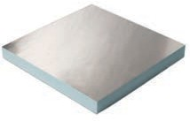
AD-PIR-S-30-10
Thickness : 30 mm
Minimum density : 55 kg/m3
Dimensions : 4000 mm x 1200 mm and 3000 mm x 1200 mm Aluminium foil finish : smooth / embossed
Aluminium foil thickness : 80 micron / 80 micron


AD-PIR-S-30-20
Thickness : 30 mm
Minimum density : 60 kg/m3
Dimensions : 4000 mm x 1200 mm and 3000 mm x 1200 mm Aluminium foil finish : smooth / embossed
Aluminium foil thickness : 80 micron / 200 micron

ALPHA-PIR-PLUS PANELS

ALPHA-PIR-PLUS panels are developed and used specifically in projects with high end hygiene specifications like hospitals, food and beverage industry and pharmaceutical industry where the surface resistance of the duct system against bacteria and microbes is essential and critical.
ALPHA-PIR-PLUS panels consist of a formaldehyde free, fiber free, high performance rigid thermoset Polyisocyanurate foam core faced on both sides with an extremely durable, protective, low vapor permeability aluminium foil.
The foam core is produced using a CFC / HCFC free blowing agent having a zero Ozone Depletion Potential (ODP) and a Global Warming Potential (GWP) lower than 5.
The aluminium foil is bonded to the foam core by heat reaction during the manufacturing process without using additional adhesives.
ALPHA-PIR-PLUS panels are manufactured using an aluminium foil facer with a special coating to provide the necessary resistance against bacteria and microbes.
ALPHA-PIR-PLUS panels are tested and verified for resistance against bacteria and microbes growth as per the following codes and standards:
- Bacteriological Analytical Manual USFDA January 2001.
- Compendium of Methods for the Microbiological Examination of Foods, APHA, 5th Edition.
- ISO 11731:2017, Second edition 05-2017, Water Quality.
- Manual of Microbiological Methods for the Food and Drink Industry, Campden and Chorleywood Food Research Association.

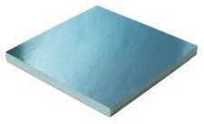
AD-PIR-PLUS-20-10
Thickness : 20mm
Minimum density : 55 kg/m3
Dimensions : 4000 mm x 1200 mm and 3000 mm x 1200 mm Aluminium foil finish : smooth / embossed
Aluminium foil thickness : 80 micron / 80 micron


AD-PIR-PLUS-20-20
Thickness : 20mm
Minimum density : 60 kg/m3
Dimensions : 4000 mm x 1200 mm and 3000 mm x 1200 mm Aluminium foil finish : smooth / embossed
Aluminium foil thickness : 80 micron / 200 micron

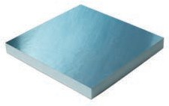
AD-PIR-PLUS-30-10
Thickness : 30mm
Minimum density : 55 kg/m3
Dimensions : 4000 mm x 1200 mm and 3000 mm x 1200 mm Aluminium foil finish : smooth / embossed
Aluminium foil thickness : 80 micron / 80 micron


AD-PIR-PLUS-30-20
Thickness : 30mm
Minimum density : 60 kg/m3
Dimensions : 4000 mm x 1200 mm and 3000 mm x 1200 mm Aluminium foil finish : smooth / embossed
Aluminium foil thickness : 80 micron / 200 micron

ACCESSORIES

ALUMINIUM INVISIBLE FLANGE

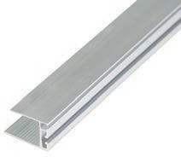
AD-F-AIF-20
Size : 20 mm
Length : 4 m

AD-F-AIF-30
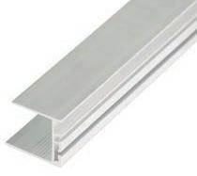
Size : 30 mm
Length : 4 m

ALUMINIUM INVISIBLE FLANGE-BLUE
For usage with ALPHA-PIR-PLUS duct system

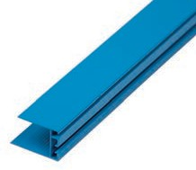
AD-F-AIFB-20
Size : 20 mm
Length : 4 m

AD-F-AIFB-30
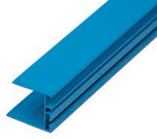
Size : 30 mm
Length : 4 m

POLYMER INVISIBLE FLANGE

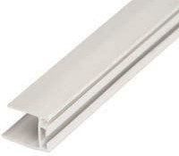
AD-F-PIF-20
Size : 20 mm
Length : 4 m

POLYMER H BAYONET

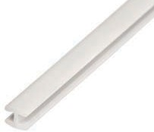
AD-F-PHB-20/30
Length : 4 m

POLYMER INVISIBLE FLANGE-BLUE
For usage with ALPHA-PIR-PLUS duct system

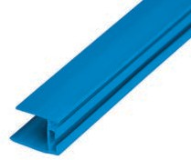
AD-F-PIFB-20
Size : 20 mm
Length : 4 m

ALUMINIUM CHAIR FLANGE

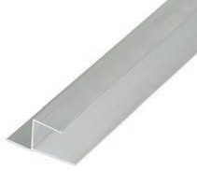
AD-F-ACF-20
Size : 20 mm
Length : 4 m

AD-F-ACF-30
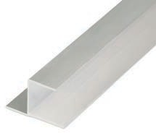
Size : 30 mm
Length : 4 m

ALUMINIUM CHAIR FLANGE-BLUE
For usage with ALPHA-PIR-PLUS duct system

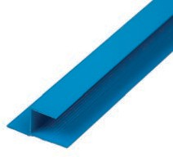
AD-F-ACFB-20
Size : 20 mm
Length : 4 m

AD-F-ACFB-30
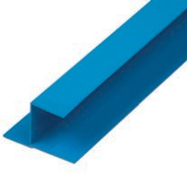
Size : 30 mm
Length : 4 m

ALUMINIUM U FLANGE

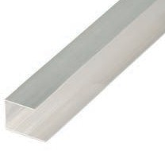
AD-F-AUF-20
Size : 20 mm
Length : 4 m

AD-F-AUF-30
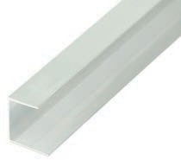
Size : 30 mm
Length : 4 m

ALUMINIUM U FLANGE-BLUE
For usage with ALPHA-PIR-PLUS duct system

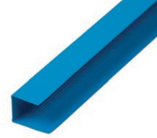
AD-F-AUFB-20
Size : 20 mm
Length : 4 m

AD-F-AUFB-30
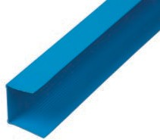
Size : 30 mm
Length : 4 m

ALUMINIUM F FLANGE

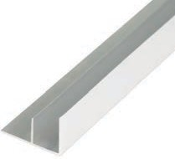
AD-F-AFF-20
Size : 20 mm
Length : 4 m

AD-F-AFF-30
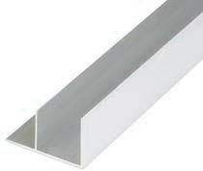
Size : 30 mm
Length : 4 m

ALUMINIUM F FLANGE-BLUE
For usage with ALPHA-PIR-PLUS duct system

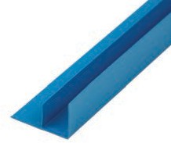
AD-F-AFFB-20
Size : 20 mm
Length : 4 m

AD-F-AFFB-30
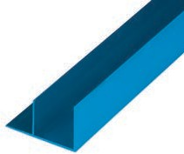
Size : 30 mm
Length : 4 m

POLYMER COVERING ANGLE

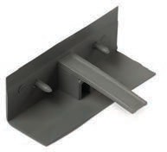
AD-F-PCA-20
Width / Height: 30 mm Length : 78 mm

AD-F-PCA-30
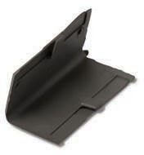
Width / Height: 40 mm Length : 78 mm

POLYMER COVERING ANGLE-BLUE
For usage with ALPHA-PIR-PLUS duct system

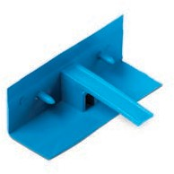
AD-F-PCAB-20
Width / Height: 30 mm Length : 78 mm

AD-F-PCAB-30
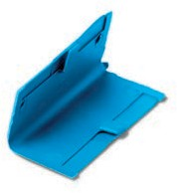
Width / Height: 40 mm Length : 78 mm

GALVANIZED CORNER

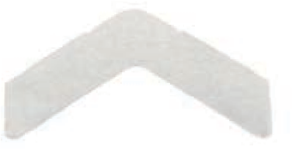
AD-F-GIC-20
Size : 20 mm
Length : 80 mm

AD-F-GIC-30
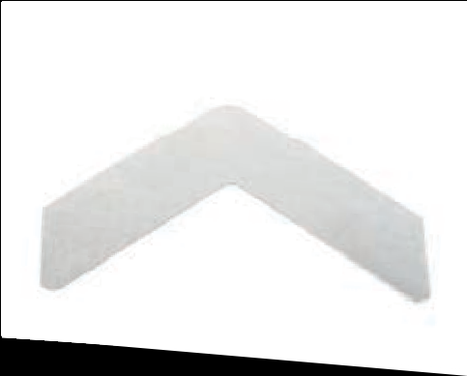
Size : 30 mm
Length : 100 mm

ALUMINIUM REINFORCEMENT BAR

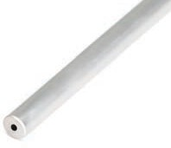
AD-F-ARB
Diameter : 14 mm
Length : 4 m

POLYMER CROSS FIXING CONNECTOR

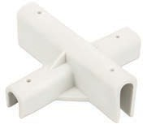
AD-F-PCFC
Length : 118 mm
Width : 118 mm

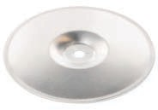
ALUMINIUM DISC

AD-F-AD
Diameter : 96 mm

SELF TAPPING SCREW

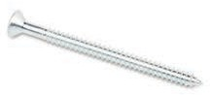
AD-F-STS
Diameter : 5.5 mm
Length : 75 mm

ALPHA DUCTS SPECIAL FOAM GLUE

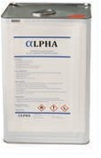
AD-F-AG-14
Weight : 14 kg

AD-F-AG-12
Weight : 12 kg

AD-F-AG-10
Weight : 10 kg

ALPHA DUCTS ACRYLIC SEALANT

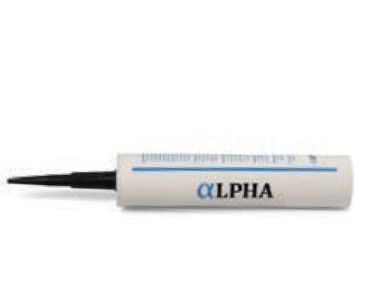
AD-F-ASL-W
Weight : 400 g
Color : White

AD-F-ASL-G
Weight : 400 g
Color : Grey

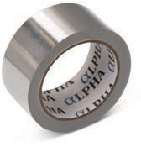
ALUMINIUM TAPE

AD-F-AT-50-25
Width : 50 mm
Length : 22.86 m

AD-F-AT-75-25
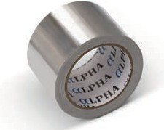
Width : 75 mm
Length : 22.86 m

ALUMINIUM REINFORCED TAPE

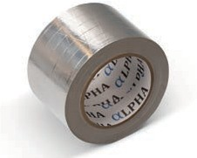
AD-F-ART-75
Width : 75 mm
Length : 45.72 m

ALUMINIUM TIGER CONNECTOR

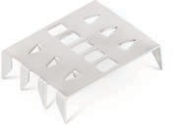
AD-F-ATC
Length : 50 mm
Width : 40 mm

MANUAL FABRICATION TOOLS

ALPHA DUCTS LLC have specifically developed a complete range of high quality hand tools for manual fabrication of
ALPHA pre-insulated air duct systems enabling fast, efficient and economical fabrication operations.
These tools are portable and easy to handle thus removing any restraints related to location and allowing fabrication on site.

MANUAL FABRICATION TOOL KIT

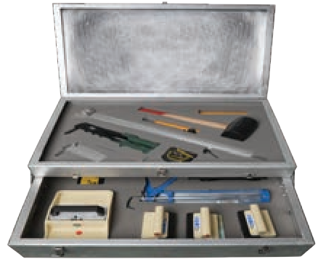
AD-F-TB-10

Single blade : Left / 45O cutter
Single blade : Right / 45O cutter
Single blade : Straight / 90O cutter
Double blade : 45O cutter
Manual silicon gun Stiff spatula
Tape marker Rubber hammer Compass
Knife Measuring tape

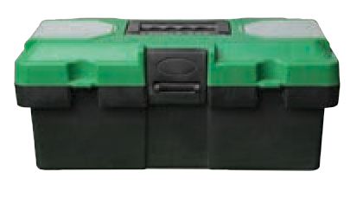
AD-F-TB-5
Single blade : Left / 45O cutter
Single blade : Right / 45O cutter
Single blade : Straight / 90O cutter
Double blade : 45O cutter

SINGLE BLADE CUTTER

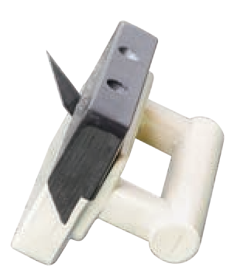
AD-F-SBC-L
Orientation : Left / 45° Panel : 20 mm and
thickness 30 mm

AD-F-SBC-R
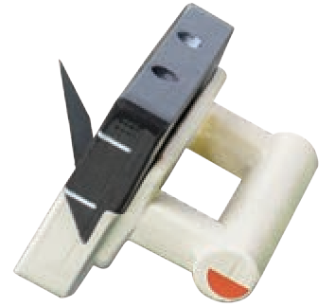
Orientation : Right / 45° Panel : 20 mm and
thickness 30 mm

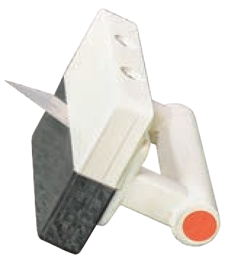
AD-F-SBC-S
Orientation : Straight / 90° Panel : 20 mm and
thickness 30 mm

DOUBLE BLADE CUTTER

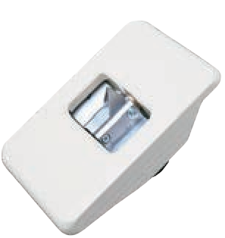
AD-F-DBC-125
Angle : 12.5°
Panel : 20 mm and
thickness 30 mm

AD-F- DBC-225

Angle : 22.5°
Panel : 20 mm and
thickness 30 mm

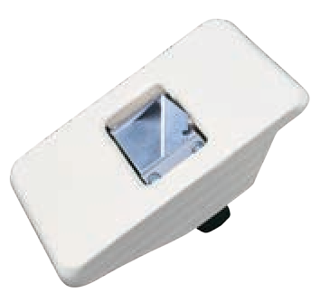
AD-F-DBC-450
Angle : 45°
Panel : 20 mm and
thickness 30 mm

AD-F- DBC-600
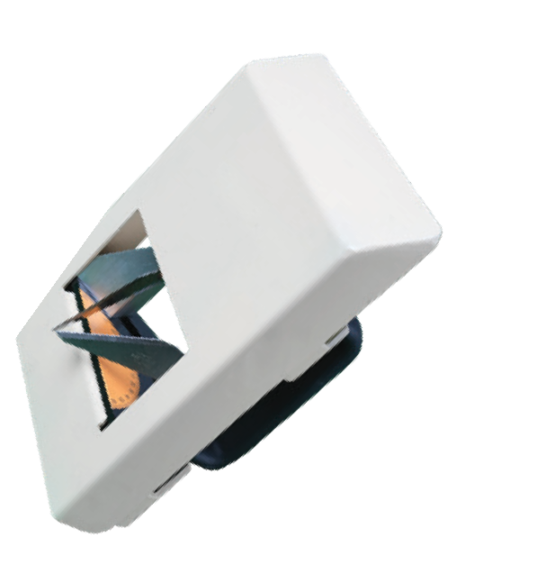
Angle : Adjustable
Panel : 20 mm and
thickness 30 mm

SQUARE IN ALUMINIUM

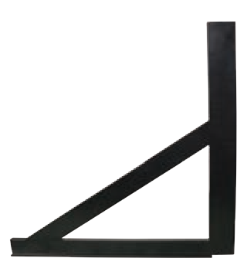
AD-F-SQR-10
Size : 1200 mm

AD-F-SQR-20
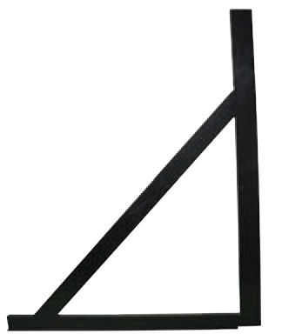
Size : 700 mm

MANUAL BENDING MACHINE
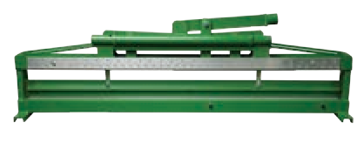
AD-F-MBMC

PNEUMATIC GLUE SPREADER
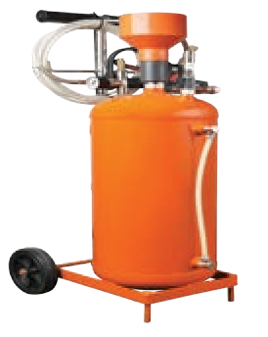
AD-F-PGS

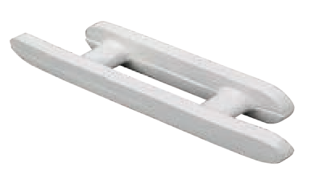
TAPE MARKER

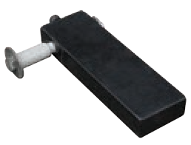
AD-F-TPMK

STIFF SPATULA

AD-F-SPTL

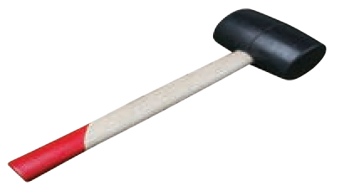
RUBBER HAMMER

AD-F-RBHM

COMPASS

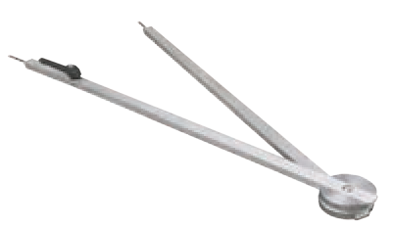
AD-F-CPS

ALUMINIUM CLAMPING RULER

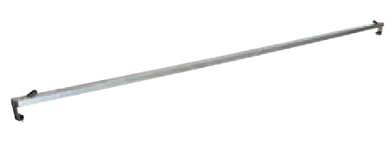
AD-F-CLR-40
Length : 4 m

AD-F-CLR-12
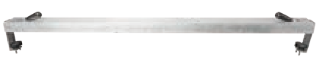
Length : 1.2 m

PORTABLE FABRICATION TABLE

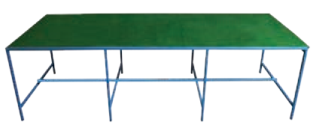
AD-F-PTL-40
Length : 4 m x 1.2 m

ICONIC PROJECTS
ALPHA pre-insulated air duct systems were used in a variety of prestigious projects covering many building categories like shopping malls, mixed use high rise towers, hotels, community villas and buildings, airport terminals in addition to many more.

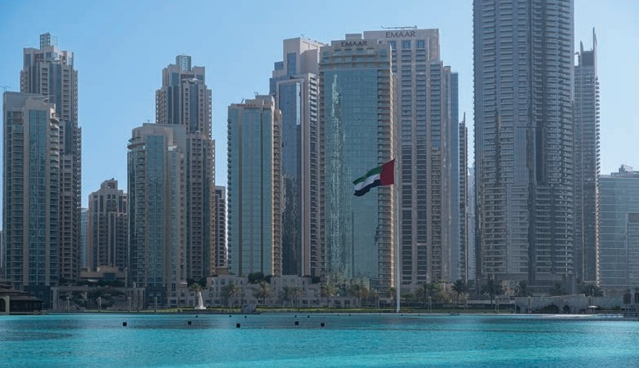
THE RESIDENCES DOWNTOWN DUBAI
CONSULTANT : HYDER CONSULTING / ARIF AND BINTOAK
PRODUCT : ALPHA-PIR
: EMAAR
CLIENT


IBN BATTUTA MALL

CLIENT : NAKHEEL CONSULTANT : DEWAN AL EMARA PRODUCT : ALPHA-PIR

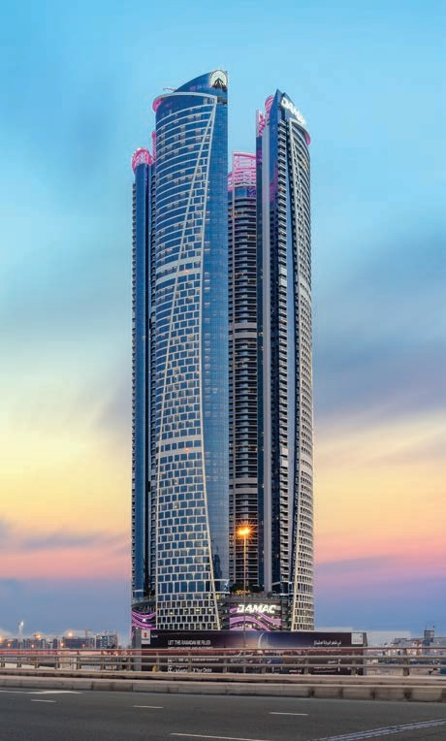

DAMAC TOWERS
BY PARAMOUNT
CLIENT
: DAMAC PROPERTIES
CONSULTANT : KEO / KHATIB AND ALAMI
PRODUCT : ALPHA-PIR

MARINA PROMENADE
CONSULTANT : HYDER CONSULTING
PRODUCT : ALPHA-PIR
: EMAAR
CLIENT


THE RITZ-CARLTON,
CONSULTANT : HYDER CONSULTING
PRODUCT : ALPHA-PIR
: UNION PROPERTIES
CLIENT
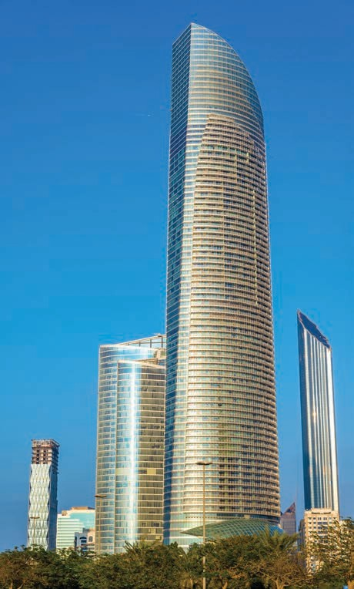
Dubai International Financial Centre
THE LANDMARK TOWER ABU DHABI
CLIENT
: DEPARTMENT OF PRESIDENTIAL AFFAIRS
CONSULTANT : BURO HAPPOLD
PRODUCT : ALPHA-PIR

ALPHA DUCTS LLC reserves the right to amend the product specifications without prior notice. Product thickness mentioned should not be considered as available in ex-stock. Final approval must always be obtained from the local Engineer / Authorities prior to the commencement of fabrication and installation.
ALPHA DUCTS LLC believes that the information and recommendations in this catalogue are accurate and reliable. However, since the installation and the usage conditions are not under the control of ALPHA DUCTS LLC, the final performance of the system is the responsibility of the customer.

ALPHA DUCTS LLC
P.O. Box 336769 Dubai, United Arab Emirates
Phone : +971 4 2724715
Fax : +971 4 2724904
Mail : info@alphaducts.com Website : www.alphaducts.com


MEP for a Better Living

